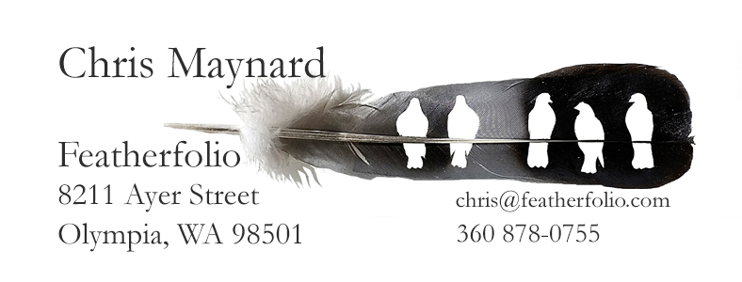

Enclosed are fliers describing special wall installations of my feather carvings. You can share these with your client.

If you need more fliers, they can be downloaded as PDF files from the bottom of this page on my website. https://www.featherfolio.com/installations

Of course, I am also happy to work with you to obtain my framed shadowbox art.

Warm wishes,

Chris

Chris Maynard
Featherfolio LLC
+1 360 878-0755
chris@featherfolio.com
Featherfolio.com

Enclosed are fliers describing special wall installations of my feather carvings. You can share these with your client.

If you need more fliers, they can be downloaded as PDF files from the bottom of this page on my website. https://www.featherfolio.com/installations

Of course, I am also happy to work with you to obtain my framed shadowbox art.

Warm wishes,

Chris

Chris Maynard
Featherfolio LLC
+1 360 878-0755
chris@featherfolio.com
Featherfolio.com

